|  |  |
| --- | --- |
| Team ID | PNT2022TMID19657 |
| Project Name | Smart Waste Management System For Metropolitan Cities |

Project Development - Delivery Of Sprint-3

# Methodology:

The conveyor belt motor engages as the waste arrives, and the conveyor belt commences to move. Many of the motors and controls, as well as the microcontroller, have been switched on. With a significantly extending people and in this Covid pandemic, it is extensively more basic to be benevolent concerning how well we, individuals, manage our prosperity and environment. Considering the insights, it is seen that authentic clinical trash evacuation is especially expected for a spotless environment. The modernized waste segregator is a capable and monetary waste combination structure with a base proportion of human mediation and besides makes no risk human life. Using a vehicle line makes the system significantly more accurate, monetarily canny, and besides clearer to put in and use at a local level. Segregating these misfortunes at a local level in like manner will be timesaving. The proposed structure fulfils the requirement for reliable watches out for garbage content in the containers.It helps with disposing of the waste material before it floods from the canisters. So standard noticing and recommending make the structure significant in waste the board. This prompts an immaculate city for better living.

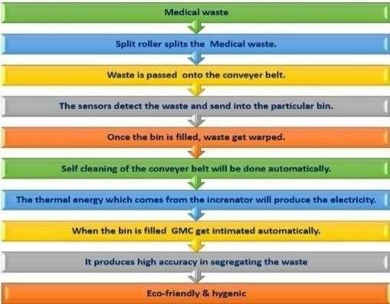

# Optimal Path Planning Algorithm for Waste Collection:

Step 1: Set up the microcontroller and all of the sensors. Step 2: Switch on the ESP8266 and initialise the SIM.

Step 3: When Wi-Fi is open, the mobile device connects to the network using an IP address. Step 4: When the height and weight of the bins exceed the margin, an SMS message is sent. Step 5: Using the IP Address on the HTML tab, you can check the status of the bins.

